Teacher Assigned WBL Projects 
* Purpose: to assign WBL projects to a class or group.

Step 1: Go to Accounts Tab and under accounts you will click on “Add/Manage Student Project Groups”

Step 2: Click green plus to “Create New Project for Students”
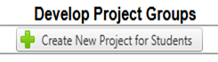
Step 3: Select one or multiple students that you would like to add to the group then Click “Add Project”
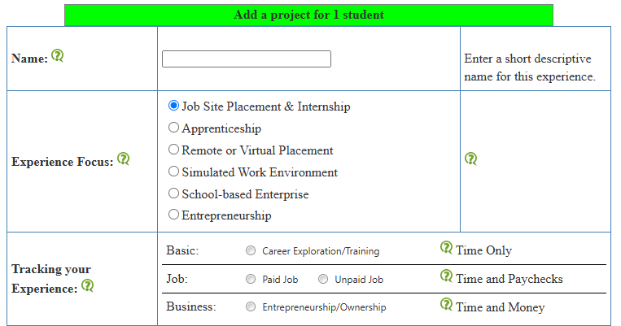
Step 4: Create the WBL
- Name: (give the project a name)
- Experience Focus:
(select the type of WBL)
- Tracking your Experience:
(what kind of records should they keep)
- Teacher Supervisor: (school supervisor/teacher)
- External Supervisor/Employer: (you can connect students with employers here)
- Primary and Secondary Experience: (chose what type of experience matches the WBL)
Step 5: Hit “Add Project for Students”


